-------------------------------------------------------------------------------------------------------------------------------NAME: ARCHANA DEVI.P
REG NO: 192521192
COURSE: SOFTWARE TESTING
CODE: CSA0923
LAB PROGRAMS
30. Find the Length of a String Without Using the Built-in length() Method
Aim
To write a Java program to find the length of a string without using the built-in length() method and validate the output using JUnit test cases and white-box testing techniques.
Algorithm
- Start.
- Read the input string.
- Convert the string into a character array.
- Initialize a counter to zero.
- Traverse the character array and increment the counter for every character.
- Return the counter value.
- Verify the result using JUnit assertions.
- Stop.
Program: StringLength.java
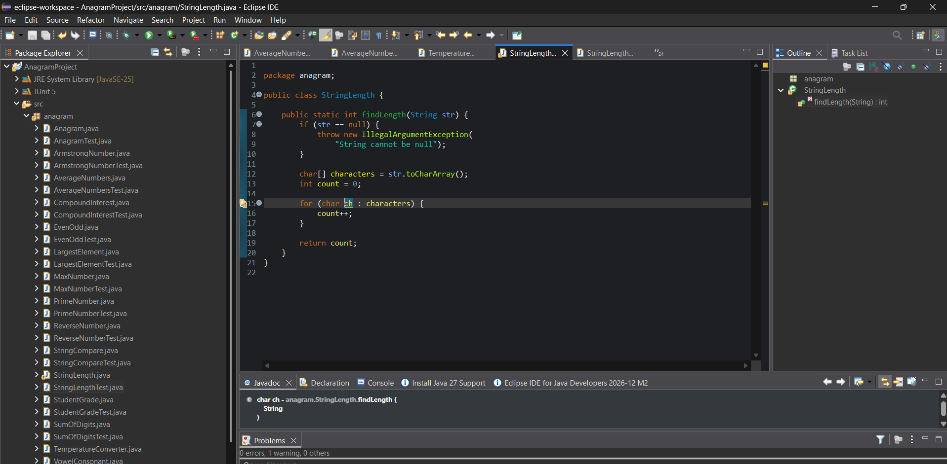
JUnit Test Case: StringLengthTest.java
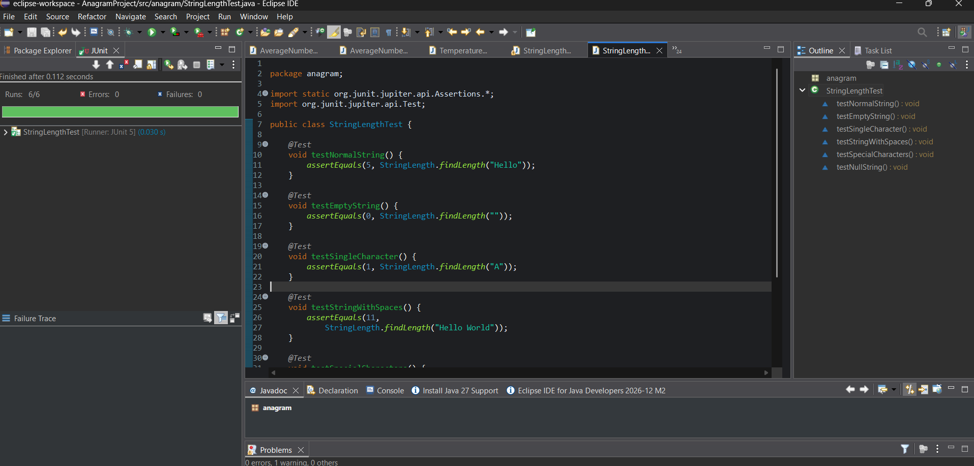
White-Box Testing
- Check the loop for an empty string and a non-empty string.
- Verify that the counter increments for every character, including spaces.
- Test a single-character string and a string containing special characters.
- Verify that a null input throws the expected exception.
Result
The Java program to find the length of a string without using the built-in length() method was implemented successfully. The output can be validated using JUnit 5 test cases and white-box testing techniques.

